Eidon UWF ERM with OCT scan

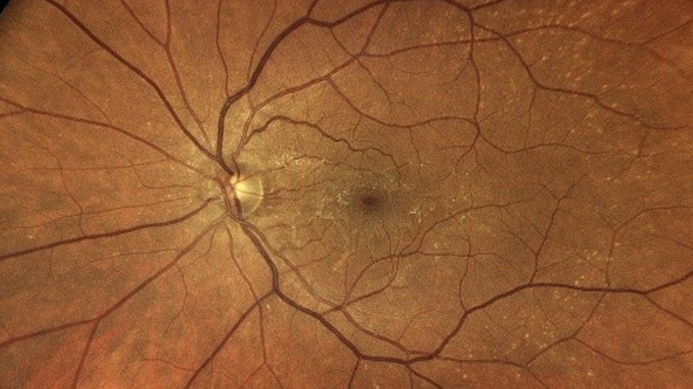

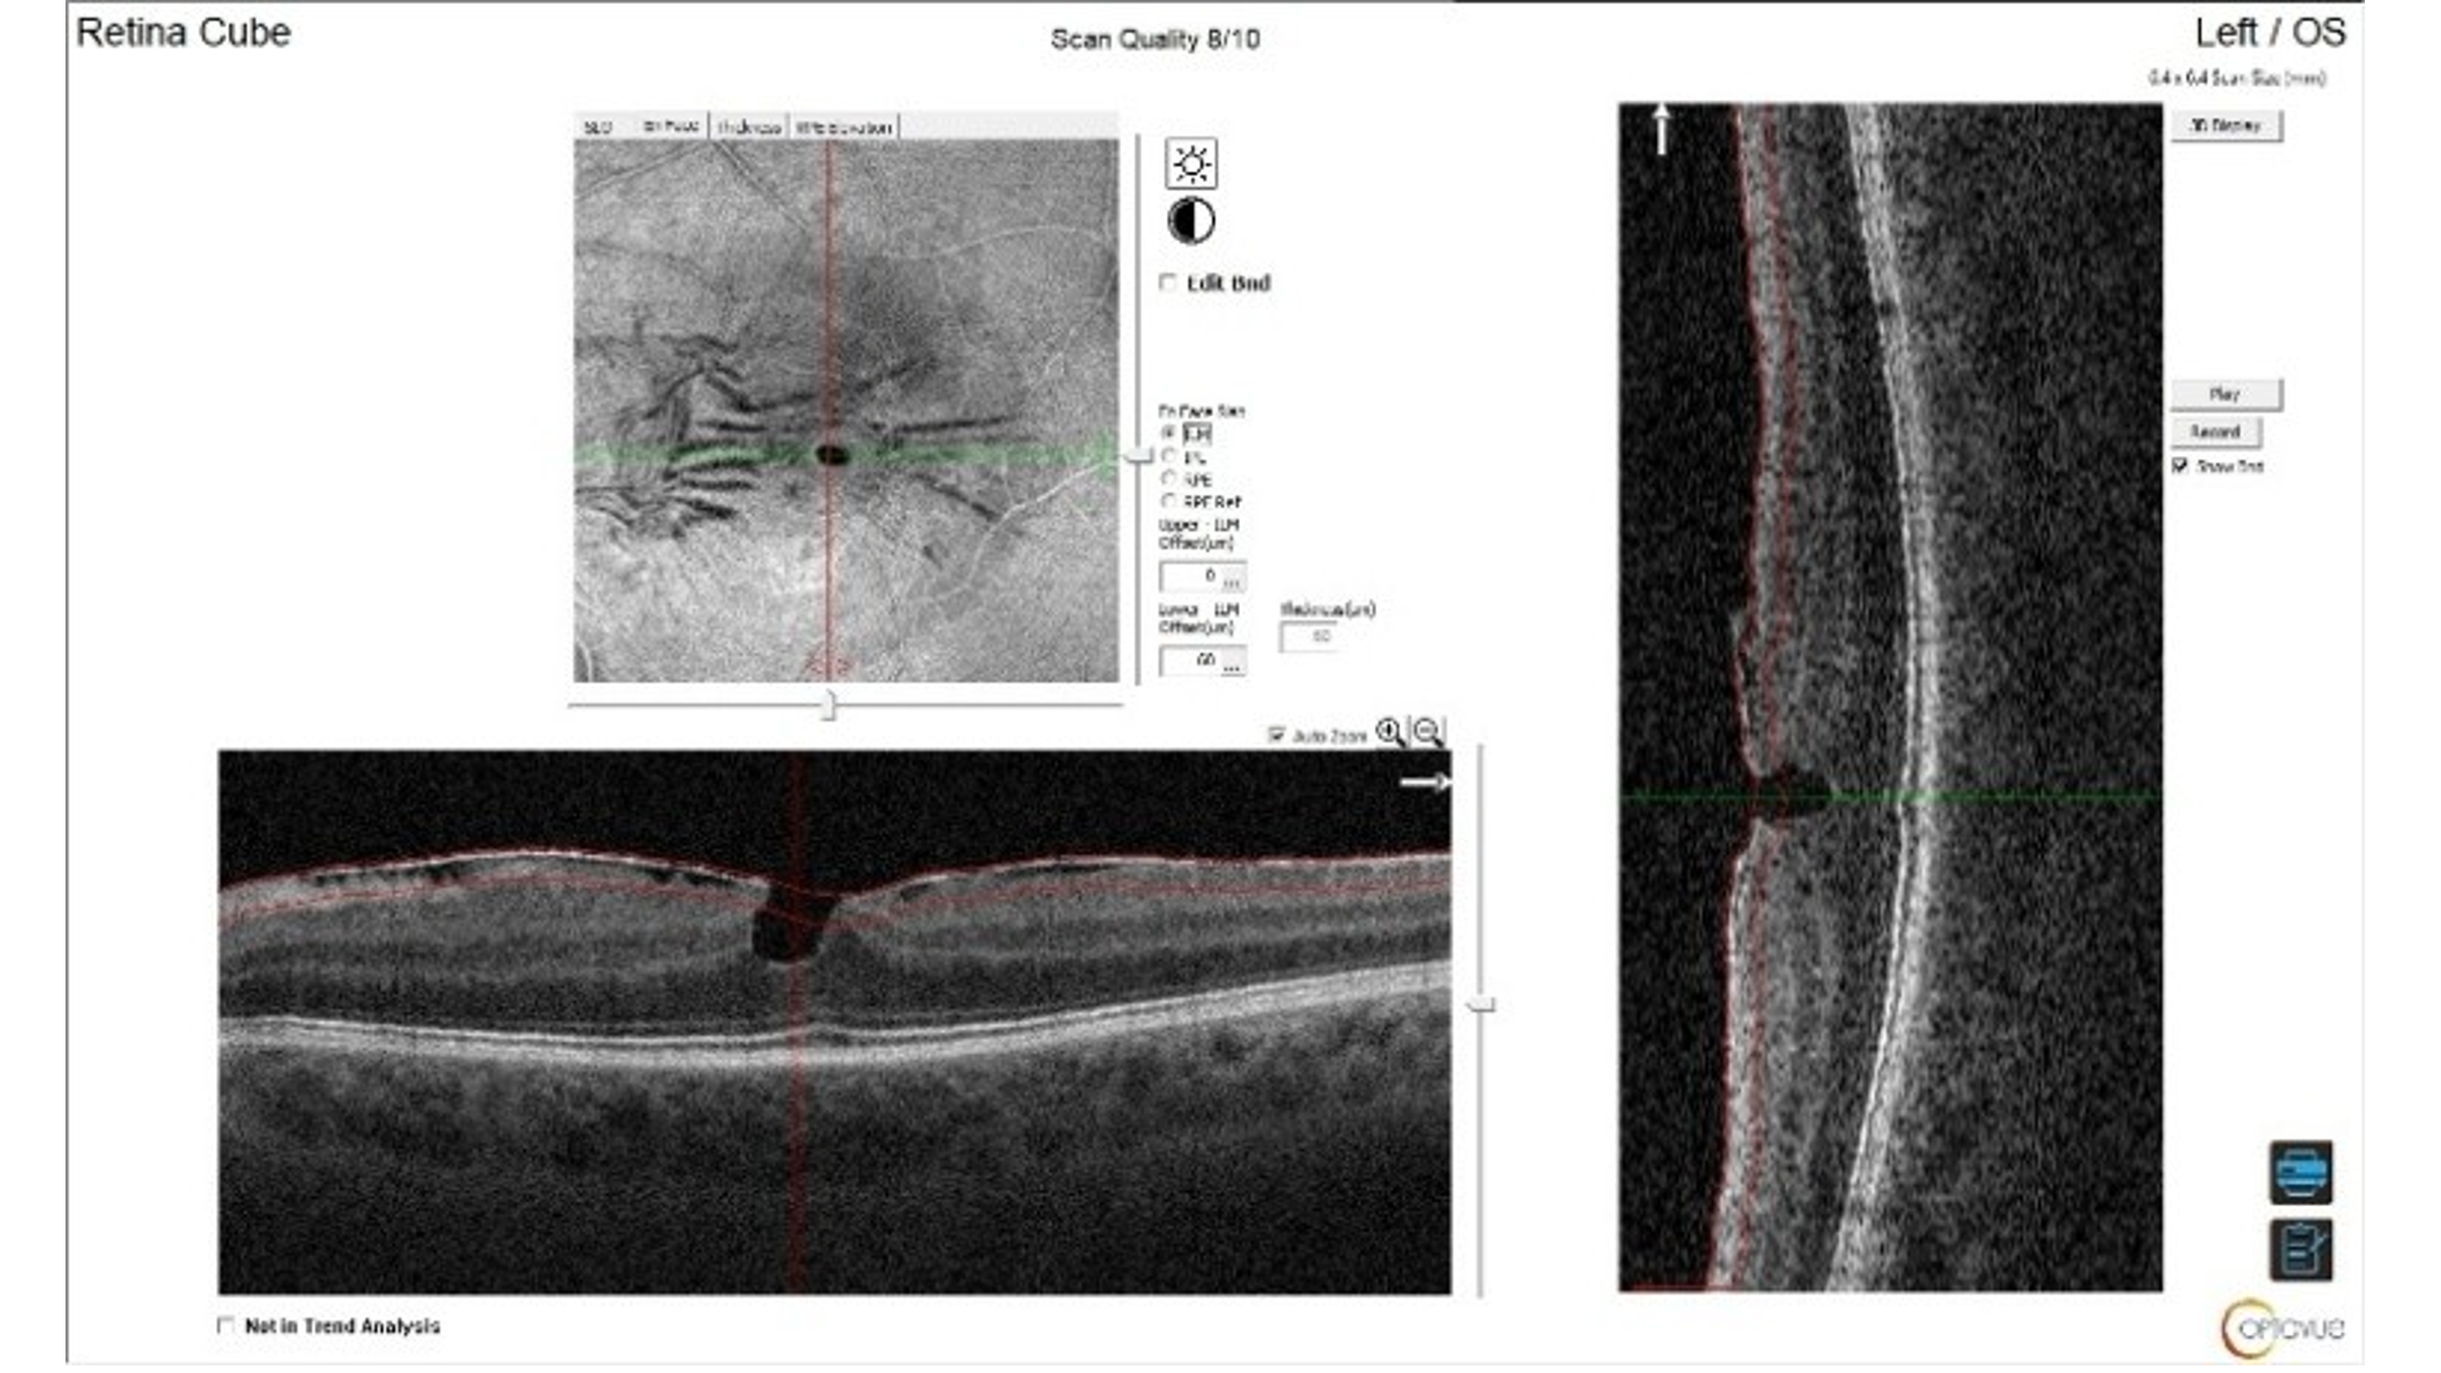

Optivue OCT Image  Eidon UWL Images courtesy of Mile Brujic OD, FAAO